**Program Statement 1**

Three switches are connected to PORTB pins RB0, RB1 and RB2. We would like to show the vehicle turn indicator and hazard light signals using these keys with the following rules. Write a single program that performs the following functions. When the key connected to RB0 is pressed, the LEDs connected to RD7 and RD6 will blink at 1 second interval. When the key connected to RB1 is pressed, the LEDs connected to RD0 and RD1 will blink at 1 second interval. When the key RB2 is pressed, then the LEDs connected to RD0, RD1, RD2, RD5, RD6 and RD7 will blink at 1 second interval. Test the program and take relevant screen shots of the output from PICSIMLAB. Follow the submission guidelines.

**Interface Diagram:**

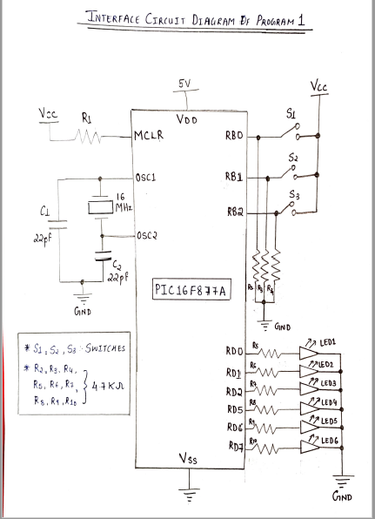

**Code:**

void Blink(unsigned char LED_Sel)

{

PORTD= LED_Sel; // PORTD LED Selection

delay_ms(1000); // One second delay

PORTD= 0x00; // All LEDs are OFF

delay_ms(1000); // One second delay

}

void main()

{

int buttonPressedCheck= 3; // Default Initialization

TRISB= 0x07; // PORTB as Input

TRISD= 0x00; // PORTD as Output

while(1)

{

if (PORTB.B0 == 0 || buttonPressedCheck== 0) // If Port RBO is Pressed

{

buttonPressedCheck= 0;

Blink(0xC0); // RD7 and RD6 will blink continuously

}

if (PORTB.B1 == 0 || buttonPressedCheck== 1) // If Port RB1 is Pressed

{

buttonPressedCheck= 1;

Blink(0x03); // RD0 and RD1 will blink continuously

}

if(PORTB.B2 == 0 || buttonPressedCheck== 2) // If Port RB2 is Pressed

{

buttonPressedCheck= 2;

Blink(0xE7); // RD0, RD1, RD2, RD5, RD6 and RD7 will blink continuously

}

}

}

**PICSimLab Results and Output:**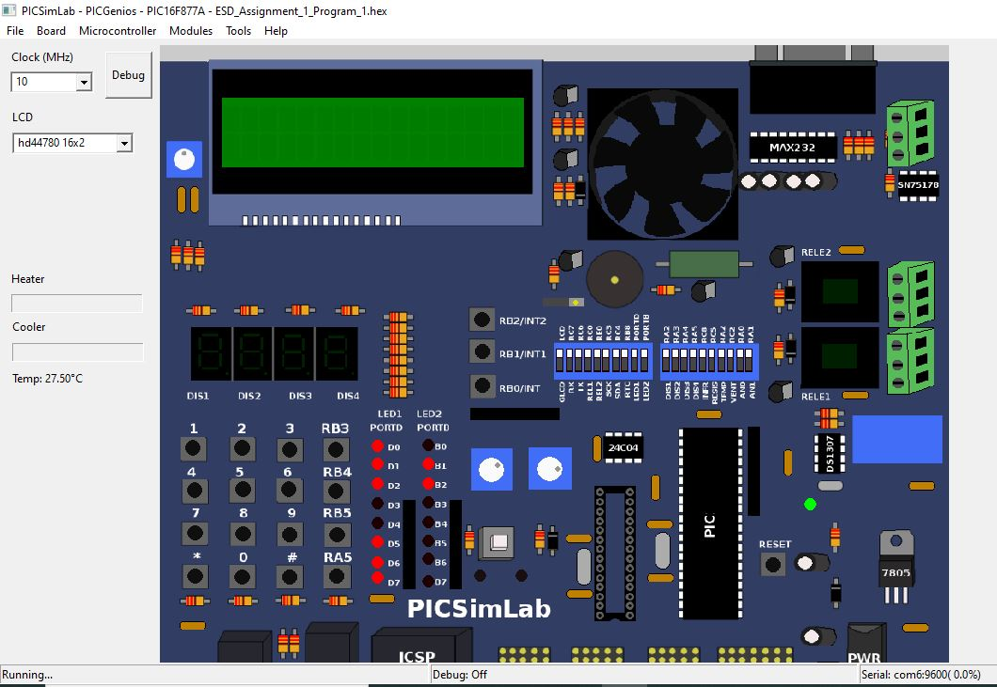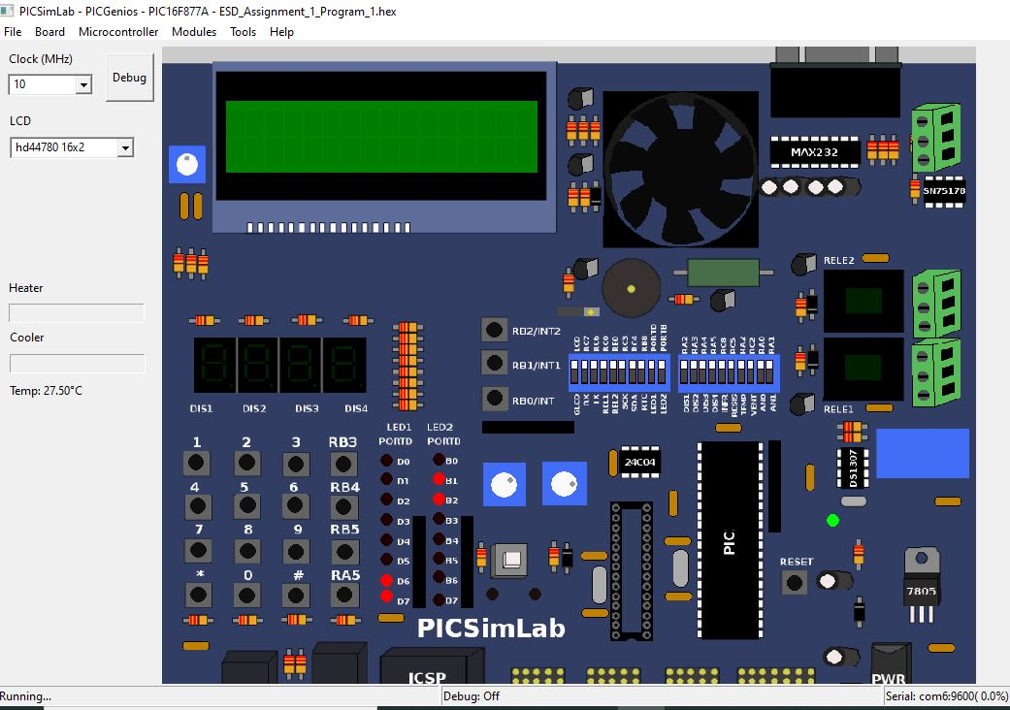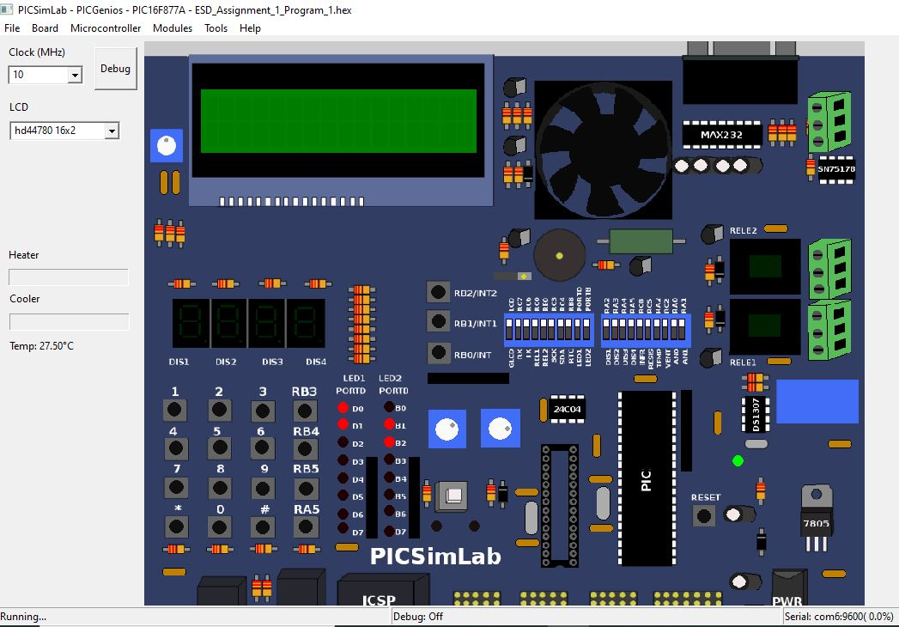

**Code Description:**   
1. Made PORTB (B0, B1 and B2) as input (The three switches are connected to these 3 ports).  
2. Made PORTD as Output. The eight LEDs are connected to PORTD (0-7 Ports).

3. Initialized variable ‘buttonPressedCheck’ to ‘3’. The purpose of this variable is to check in which state the PORTD is. For ex, Left or Right Indicators or Hazard Lights.

4. If PORTB.B0 Switch is pressed, RD7 and RD6 LEDs Blink at one second interval and ‘buttonPressedCheck’ is set to 0. It continues to be in this state until any the other switch is pressed.

5. If PORTB.B1 Switch is pressed, RD0 and RD1 LEDs Blink at one second interval and ‘buttonPressedCheck’ is set to 1. It continues to be in this state until any the other switch is pressed.

6. If PORTB.B2 Switch is pressed, RD0, RD1, RD2, RD5, RD6 and RD7 Blink at one second interval and ‘buttonPressedCheck’ is set to 2. It continues to be in this state until any the other switch is pressed.

7. Step 4 to 6 are in while loop.

**Flowchart:**

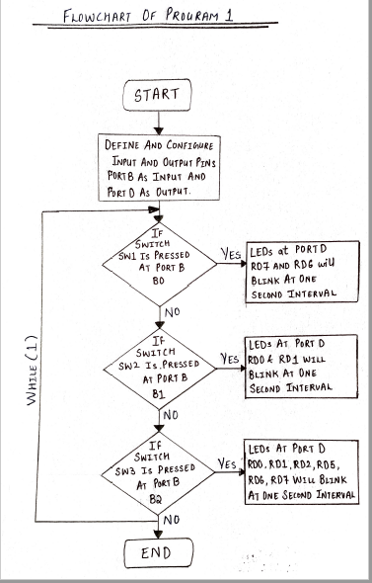

***---------------------------------END OF PROGRAM---------------------------------***

**Program Statement 2**

Display the number 1234 in the 7-segment display. If the switch connected to RB0 is pressed continuous increment the number at 1 second interval until the number reaches 1250 and stays at that number. If the switch connected to RB1 is pressed continuous, decrement the number by 1 at 1 second interval until the number reaches 1200 and stays there. If the switch connected to RB2 is pressed at any time display the number 1234. Follow the submission guidelines

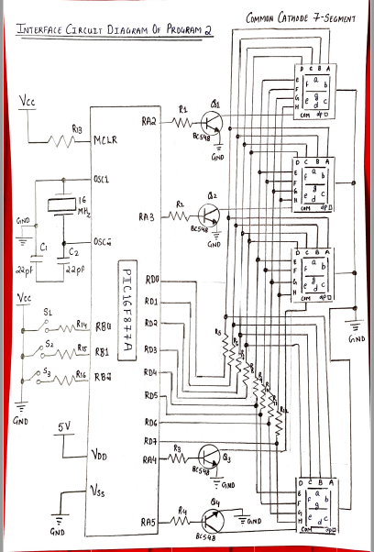**Interface Diagram**

**Code:**

unsigned char tableDigit[10]= {0x3F,0x06,0x5B,0x4F,0x66,0x6D,0x7D,0x07,0X7F,0x6f}; // Array containing Hex Value from 0-9

unsigned int countTemp= 1234; // Counter initialized to 1234

void sevenSegDisplay(unsigned int countTemp); // Function Declaration

void main()

{

TRISB = 0x07; // PORTB as Input

TRISD = 0x00; // PORTD as Output

TRISA = 0x00; // PORTA as Output

while(1)

{

if (PORTB.B2 == 0) // To check if RB2 is pressed

countTemp = 1234; // Reset Counter to 1234

if (PORTB.B0 == 0 && countTemp < 1250) // To check if RB0 Switch is pressed

{

Delay_ms(1000); // One second Delay

if (PORTB.B0 == 0) // To check if the key is pressed for one second

countTemp++; // Counter Increment

}

if (PORTB.B1 == 0 && countTemp > 1200) // To check if RB1 Switch is pressed

{

Delay_ms(1000); // One second Delay

if (PORTB.B1 == 0) // To check if the key is pressed for one second

countTemp--; // Counter Decrement

}

sevenSegDisplay(countTemp); // Display 'countTemp'

}

}

void sevenSegDisplay(unsigned int countTemp)

{

PORTA = 0x04; // Set RA2 logic high - Common Cathode

PORTD = tableDigit[(countTemp / 1000)]; // 1st Digit- Thousand's Place

Delay_ms(1); // Delay one millisecond

PORTA = 0x08; // Set RA3 logic high - Common Cathode

PORTD = tableDigit[(countTemp / 100) % 10]; // 2nd Digit- Hundred's Place

Delay_ms(1); // Delay one millisecond

PORTA = 0x10; // Set RA4 logic high - Common Cathode

PORTD = tableDigit[(countTemp / 10) % 10]; // 3rd Digit- Ten's Place

Delay_ms(1); // Delay one millisecond

PORTA = 0x20; // Set RA5 logic high - Common Cathode

PORTD = tableDigit[countTemp % 10]; // 4th Digit- Unit’s Place

Delay_ms(1); // Delay one millisecond

}

**PICSimLab Results and Output:**

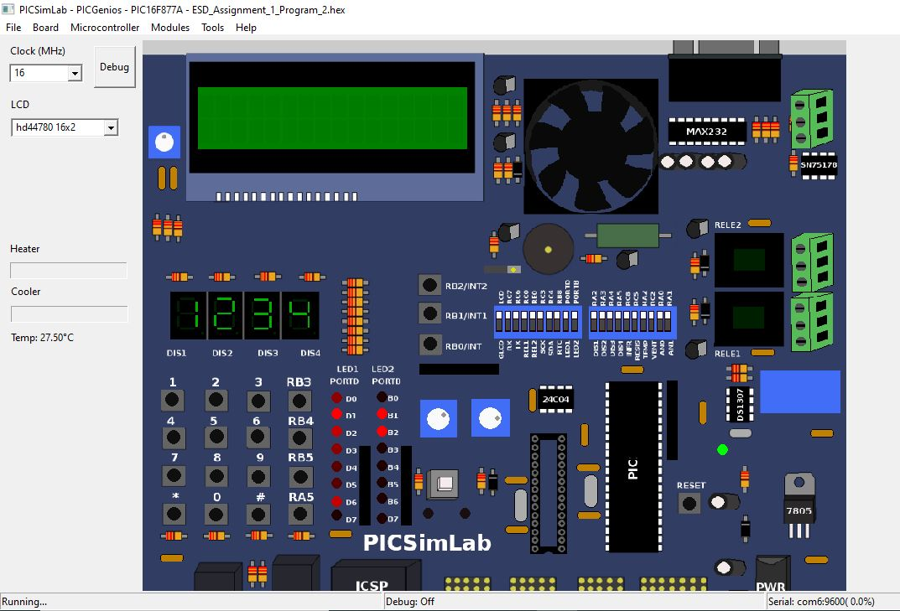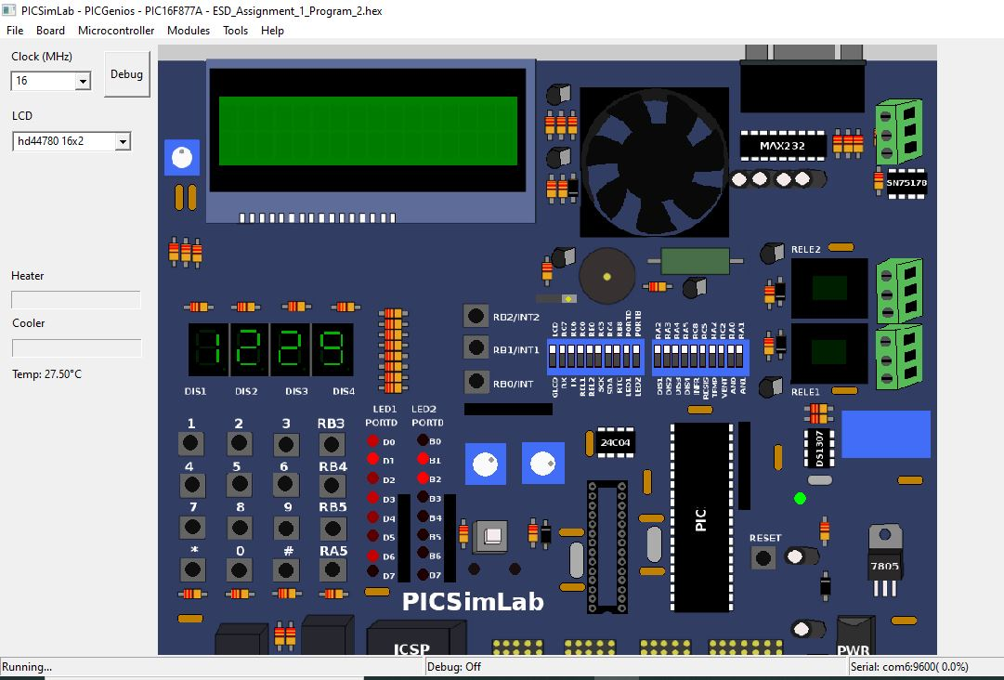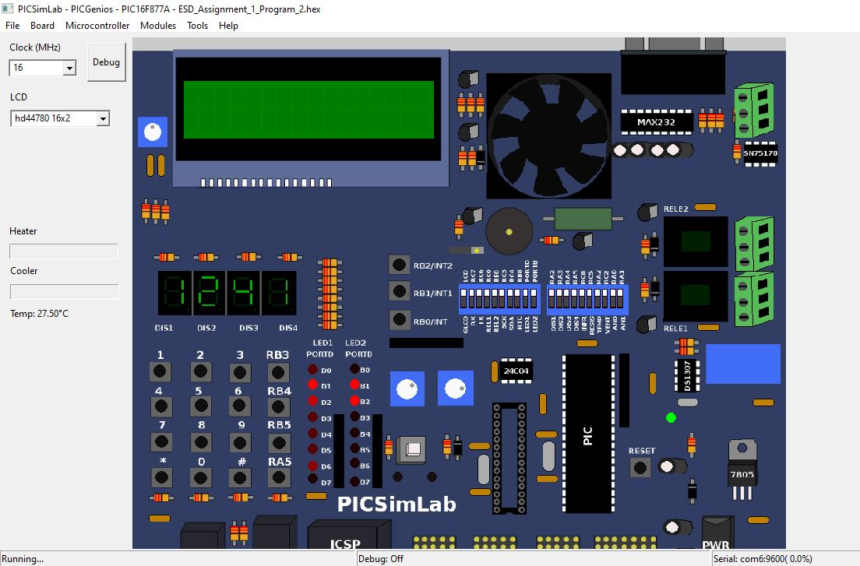

**Code Description:**   
1. Made PORTB (B0, B1 and B2) as Input (The three switches are connected to these 3 ports).  
2. Made PORTA (Selecting the 7 Segment Display) and PORTD (The LEDs of 7 Segment Display) as Output.

3. Initialized variable ‘countTemp’ to ‘1234’.

4. If PORTB.B0 Switch is pressed continuously for one second and ‘countTemp’ is less than or equal to 1250, ‘countTemp’ is incremented by one,  
the subsequent value of ‘countTemp’ is displayed on the four 7-Segment Displays.

5. If PORTB.B1 Switch is pressed continuously for one second and ‘countTemp’ is more than or equal to 1200, ‘countTemp’ is decremented by one, the subsequent value of ‘countTemp’ is displayed on the four 7-Segment Displays.

6. If PORTB.B2 Switch is pressed continuously for one second and ‘countTemp’ is set to 1234, the subsequent value of ‘countTemp’, i.e., 1234 is displayed on the four 7-Segment Displays.

7. Step 4 to 6 are in while loop.  
  
* 7-Segment Display-  
1. First, we select four 7-Segment Display (Common Cathode) using PORTA [RA2, RA3, RA4, RA5].

2. By Making RA2 high and Rest other ports of PORTA as low, we select Thousand's Place.

3. By Making RA3 high and Rest other ports of PORTA as low, we select Hundred’s Place.

4. By Making RA4 high and Rest other ports of PORTA as low, we select Ten’s Place.

5. By Making RA5 high and Rest other ports of PORTA as low, we select Unit’s Place.

6. The value of ‘countTemp’ is then distributed into four digits and displayed individually using the above method.

6. By Selecting PORTD Pins we can display the digits from 0 to 9 on 7-Segment Display.

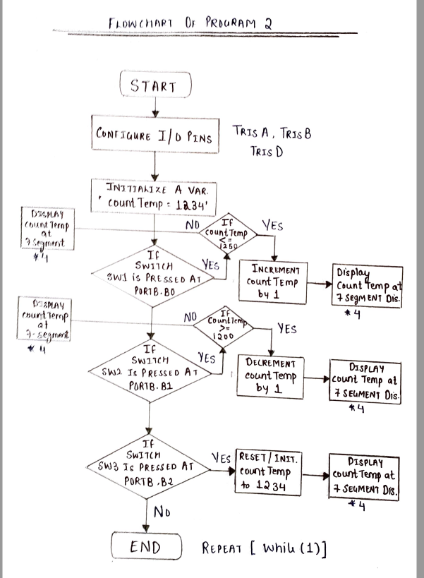**Flowchart:**

***---------------------------------END OF PROGRAM---------------------------------***